First name Last name
Title of the Thesis
Subtitle

Metropolia University of Applied Sciences
Degree
Degree Programme
Thesis
Date
Abstract
Author(s): First Name Last Name
Title: Title of the Thesis
Number of Pages: xx pages + x appendices
Date: 28 August 2020

Degree: Name of the degree
Degree Programme: Name of the degree programme
Specialisation option: Name of the specialisation option
Instructor(s): First name Last name, Title (e.g., Project Manager)
First name Last name, Title (e.g., Principal Lecturer)

The text section of the abstract is written to fit the space used on the page. The text section uses the Body Text No Spacing style.

Keywords: Keyword
___________________________________________________________

The originality of this thesis has been checked using Turnitin Originality Check service.

Contents
1 Introduction 1
2 Chapter Heading 1
2.1 Subheading 1
2.2 Subheading 2
3 Document structure 2
3.1 Tables 2
3.1.1 How to create tables in Word 3
3.1.2 Secondary subheading 3
3.2 Quotes 3
3.3 Lists 4
4 Image usage and alternative text 4
4.1 How to add alternative text to images 5
4.2 Subheading 6
5 Document accessibility 7
5.1 Finish the document properties 7
5.2 Check the accessibility of your thesis 7
5.3 Save the Word document as an accessible PDF 8
References 10
Appendices 11
Title of the Appendix 11
Title of the Appendix 13

Introduction
Write the introduction of your thesis here. Use line spacing 1.5 throughout the paper. Only the left edge is aligned, and the text is not hyphenated. Leave one blank line between paragraphs (press enter once).
Begin a new paragraph at the left margin, that is, do not indent the first line.

Chapter Heading

Subheading
There must always be text or a new subheading below each heading. Do not place a figure or table below a heading with no text in between. Label each figure and table appropriately. Provide a number, title and reference (if needed) below each figure and above each table.

Figure 1. Virtual studies completed by Metropolia students in the academic year 2009-2010.
There must always be text between a figure or table and a new heading.

Subheading
There must always be text or a new subheading below each heading.

Document structure

Tables
There must always be text or a new subheading below each heading. Do not place a figure or table below a heading with no text in between.
Table 1. Virtual studies completed by Metropolia students in the academic year 2009-2010.
Field of study | Studies completed, ECTS
Culture | 131
Technology, Communication and Transport | 552
Health Care and Social Services | 175
Business and Administration | 52
Not bound to a field of study | 18
Metropolia total | 928

There must always be text between a figure or table and a new figure or table or a new heading.

How to create tables in Word
Create tables using Word's "Add a Table" tool. Do not use an image of a table, as screen readers cannot interpret the image. Make a header row and ensure the contents of the table cells are readable in a logical order.
Once you've created a table, mark the top row of the table as the header row as follows:
- Place the mouse cursor on the top row of the table. This displays the Table Tools on the Ribbon.
- In Table Tools, click "Layout", and then click "Repeat Header Rows".
This will repeat the header of the table, even if the table divides across multiple pages.

Secondary subheading
There must always be text or a new subheading below each heading.

Quotes
There must always be text or a new subheading below each heading.
Quotes use the Quote style. The paragraph containing the citation passage (immediately before the citation) uses the Normal Text Before a Quote or List style to leave a shorter paragraph spacing between the citation and the passage.
A multi-line direct quote is written in font size 12. The text uses line spacing 1, and the text is indented. Direct quoting uses the Quote style of the template. A citation is given in the quotation.
After indentation, the text continues from the left edge in the body text style.

Lists
A list in the text uses the List style. The paragraph before a list uses the Normal text before a quote or list style.
This is the first item in the list.
The second item of the list here contains a long text that spans multiple lines. The left edge aligns automatically.
This is the first item in the list.
The fourth item in the list is here.

When the list items are sentences, they begin with a capitalized letter, and the list items end in a period.
When the list items are not sentences, they begin with a lowercase letter, and the last list item ends in a period. The thesis consists of
words
clauses
sentences
paragraphs
chapters.

Image usage and alternative text
According to accessibility requirements, images must have alternative text. Alternative text is not the same thing as a caption. Alternative text is a description of the content of an image read aloud by screen readers used by the visually impaired. It is not advisable to repeat the caption in the alternative text because screen readers read both contents.
When writing alternative text, think about what information you will not receive if you do not see the image. Use short sentences and plain language. Tell the essential about the picture - you don't have to explain everything.
Alt text can be blank for a decorative image. Decorative images are images that do not convey any information or that have been added for layout.
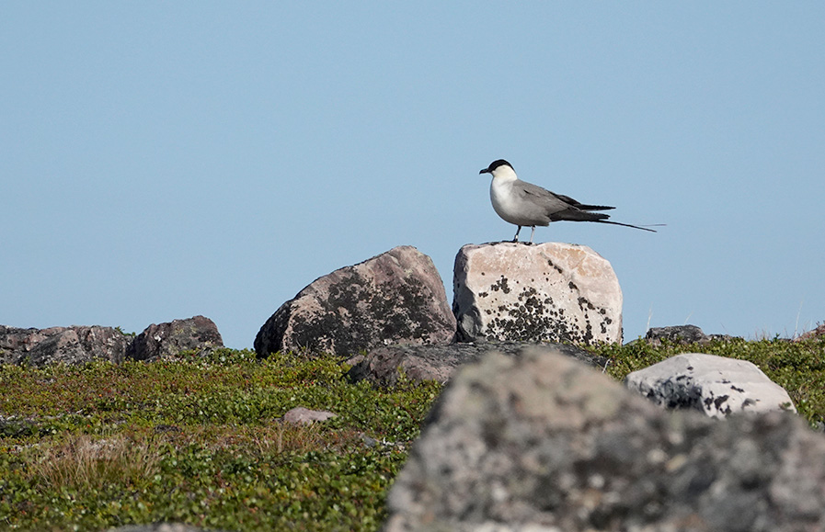
Figure 2. Long-tailed jaeger is common in Finnmark's mountain plateau in northern Norway. Its main wintering site is in the South Atlantic west of Africa.

How to add alternative text to images
An alternative text is given to an image in a Word document as follows (Office 365 version):
- Move the cursor over the image and right-click.
- Select “Edit Alt Text…” to open the Alternative Text window.
- Write a brief explanation of the essential content of the image.
- If the image is purely decorative or the caption contains all the relevant information, mark the image as decorative.
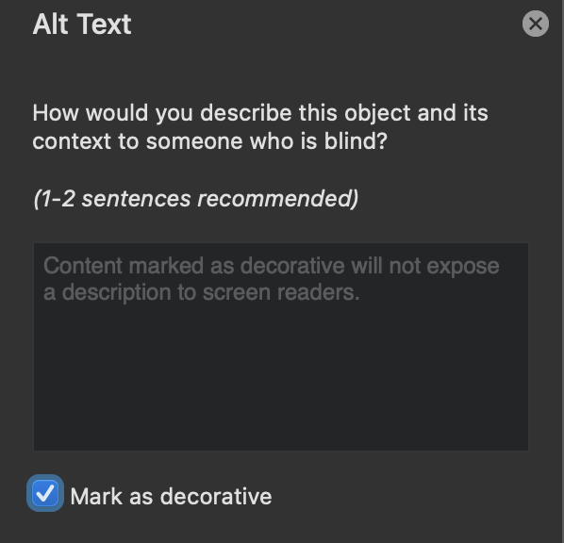
The Microsoft Office 2016 version of Word is slightly different:
- Move the cursor over the image and right-click.
- Select “Format Picture…”
- In the “Format Picture” window, select the third icon “Layout and Properties”.
- Select “Alt Text” and enter a description of the image content in “Description”. Do not write anything under “Title”.

Subheading
There must always be text or a new subheading below each heading.
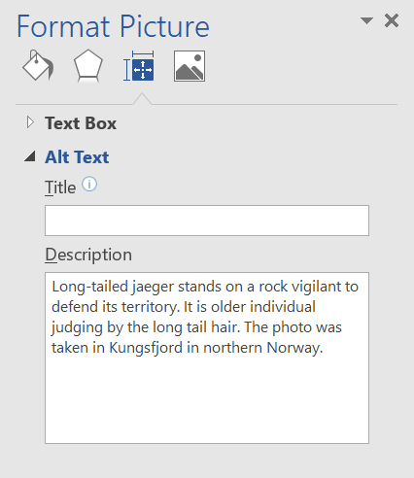

Document accessibility

Finish the document properties
Once the content of your thesis is in order, finalise the document by specifying its properties. It is essential to ensure that the pdf file is accessible when you convert a Word file to PDF format. Type a title for the document in the File menu, under Info. Enter the title of your thesis as the title.
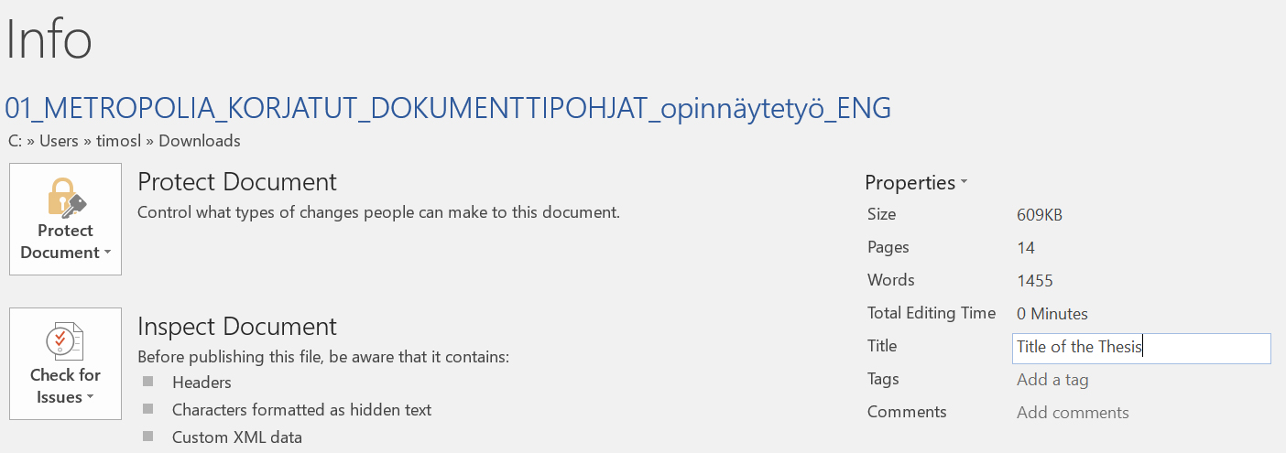

Check the accessibility of your thesis
Word has a feature that lets you check the accessibility of a document.
- On the File menu, click Info.
- Then click Check for Issues.
- Click Check Accessibility.
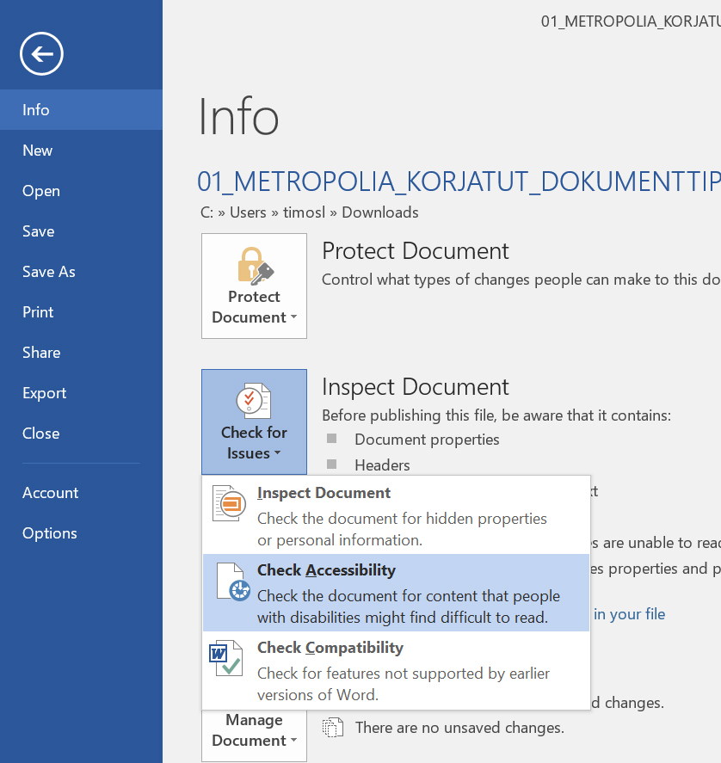
The Accessibility Check window will then appear on the right side of the Word. The results of the scan show possible errors and warnings. For more information about results, click the item name in the results list. Word also tells you the reason for the repair, as well as give repair instructions. At least fix any errors.

Save the Word document as an accessible PDF
Once you have checked your thesis for accessibility, convert it into an accessible PDF document.
- Create a PDF file using either the Export function (Create PDF) or the Save As function.
- In the save options, select Document properties and Document structure tags for accessibility.
- Click Create bookmarks using Headings.
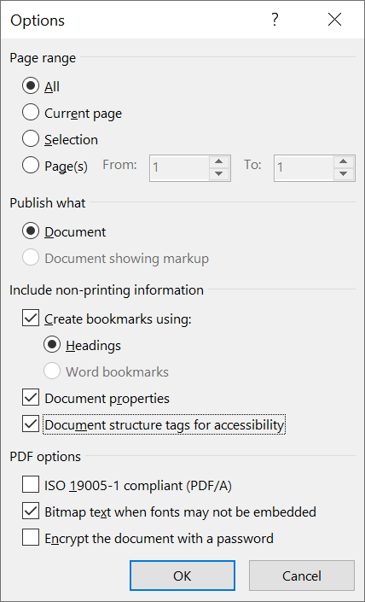
Do not use the Print to PDF function because the result is not accessible PDF.

References
Details of the references are given here. Use the referencing system required in your degree programme or as agreed with your supervisor.
Harvard (author-date) system:
The authors need to be in alphabetical order.
Davies B, Jameson P. 2013 Advanced economics. Oxford: Oxford University Press.
Mitchell, J.A. and Thomson, M. 2017 A guide to citation. London: London Publishings.

Vancouver (numbering) system:
- Mitchell, J.A. and Thomson, M. A guide to citation. London: London Publishings; 2017.
- Davies B, Jameson P. Advanced economics. Oxford: Oxford University Press; 2013.

Appendices

Title of the Appendix
The content of the appendix is ​​written here. Below are instructions for adding and removing attachments so that the headers remain the correct.
- Instructions for adding a new attachment:
- Move the cursor to the end of the last existing attachment page.
- Choose the Page Layout tab. From the Page Break ribbon select Next Page under Section Breaks. This completes the printing of the new attachment, but the number in its header is not correct.
- Double tap the header of the new attachment page with the wrong attachment number. If the “Link to previous” option is selected in the ribbon, press that button so that the option is no longer selected.
- Please correct the attachment number.
Instructions for removing an unnecessary attachment:
- First select the entire attached page and press Delete to delete its contents.
- When you are at the beginning of the attachment page you have emptied (see figure), double tap the header of the blank attachment page and press the Link to Previous button on the ribbon. The following dialogue box appears:
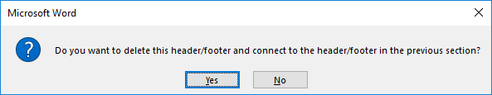
Answer Yes.
- From the Home tab, toggle hidden characters if they are not visible:.
- Remove the section break before the unnecessary attachment (see figure below).


Title of the Appendix
Content of the appendix is placed here

